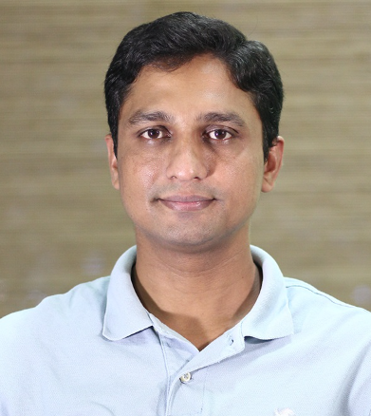
Title: Robotics and Autonomy in Minimally Invasive Surgery
Name: Nirav Patel
Present Position: Associate Professor, Department of Engineering Design, IIT Madras

Abstract: Minimally invasive surgery (MIS) has transformed patient outcomes by reducing trauma, recovery time, and complications, but it places significant demands on the surgeon: restricted access, limited visual feedback, reliance on image guidance, and the need to interact with soft, deforming tissue. Robotics offers a path to address these challenges, not only by improving dexterity and precision, but increasingly by taking on parts of the surgical workflow autonomously. In this talk, I will present our works on robotic assistance to autonomous interventions. The talk begins with image-guided neurosurgery, presenting a CT-guided robotic system for accurate instrument placement that has been evaluated in benchtop and phantom studies under preoperative CT guidance. It then turns to automated surgical planning, starting with FNPG-NH and its successor, AutoPlan, which performs fully autonomous trajectory planning for steerable needles and has been validated in phantom studies, reducing the planning burden on clinicians. The third part addresses autonomous camera control in laparoscopic surgery, where a cobot maintains a remote center of motion at the incision and positions the endoscope to keep the surgical scene in view, freeing the surgeon from depending on a human camera assistant. Finally, the talk takes up one of the open problems in surgical autonomy: manipulating deformable objects. Using physics-based models alongside learned dynamics and planning, we explore how robots can predict and control the behavior of flexible materials, a step toward reliable interaction with sutures and soft tissue.
BioSketch
Nirav Patel is currently an Associate Professor with the department of Engineering Design and leads INSPIRE Lab at IIT Madras. Before joining IIT Madras, he worked as a postdoctoral research fellow with the Laboratory for Computational Sensing and Robotics (LCSR) at the Johns Hopkins University from 2017 to 2020 under the guidance of Dr. Iulian Iordachita. He graduated with a Ph.D in Robotics Engineering from Worcester Polytechnic Institute in 2017, under the guidance of Dr. Gregory Fischer. He worked on industrial robots with ABB’s corporate research center in Bangalore till 2009. His research interests include development of image guided robotic systems for percutaneous intervention, surgical planning and motion planning for surgical robots, minimally invasive robotic surgeries and development of sensors and control strategies for safety in robot assisted minimally invasive surgeries. He is particularly interested in clinical translation of these technologies.

